Sample Records Management Training Plan at a Glance

December 2018

Mark Diamond, CEO & Founder, Contoural, Inc.

Contoural provides information regarding business, compliance and litigation trends and issues for educational and planning purposes. However, legal information is not the same as legal advice – the application of law to an individual or organization's specific circumstances. Contoural and its consultants do not provide legal advice. Readers should consult with competent legal counsel for professional assurance that our information, and any interpretation of it, is appropriate to each reader’s situation.

Putting together an effective training program involves working with a communications and training group to understand what kind of communication plans have been successful in the past in the organization and understanding what kind of platforms are available for training. A good training plan lays out the resources and responsibilities for training. Does the organization have classrooms that can be utilized? What media should organizations use to deliver trainings? To ensure a successful change in behavior, it is key to understand the particular audiences that need to be addressed, what platforms are available to deliver the training and look at the messaging that needs to be developed. Trainers Provides in-person or online training to Executives or others, as necessary

Training can assume a variety of formats including classroom, webinars, and CBT (Computer-based Training) supplemented with training aids, guides, and a list of frequently asked questions (FAQs). Training content should reflect the overall messaging that will best resonate with employees**.**

|  |  |
| --- | --- |
| Trainers | Provides in-person or online training to Executives or others, as necessary |

|  |  |
| --- | --- |
| **RESOURCE** | **RESPONSIBILITIES** |
| Executive Sponsor (John Smith) | Present information on the Records Program implementation timelines at meetings of Executive Committee, Senior Leadership, and other required meetings |
| Core Project Team | Provide awareness building and consistent messaging to all Delivery Resources and Audience Segments |
| Business Unit Leaders /  Department Leaders | Provide awareness building and overall project support to line-of-business employees and other general users |
| Records Coordinators | Provide assistance to employees throughout rollout and beyond; answer questions, build awareness |
| Intranet | System for delivering messaging to Executives and other targeted groups |
| iLearn | Provides Computer-Based Training (CBT) for Records Program |

Table 1. Sample training plan.

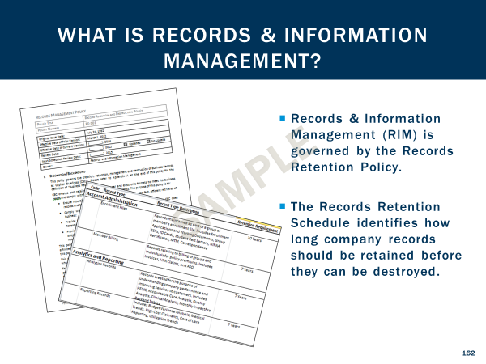

Figure 1. Sample Records Management Training

## **Additional Information on This Topic**

**Creating a Records Management Project Plan**

Records Management and Information Governance initiatives have a number of moving pieces involving many stakeholders and these complex projects are prone to get stuck or stall out. Typically the root problem of these failed efforts is not in the execution, but rather the initial project plan. This webinar discusses creating a successful records management plan.

To view the webinar, click [here](https://www.youtube.com/watch?v=OlCkvUpa8uo).

**Creating and Managing a Global Records Management Program**

Records management can be challenging for global companies that face a myriad of record retention requirements across all the countries in which they operate. Creating a compliant and accurate policy, and more important actually executing the policy can be daunting, especially for electronic information that easily crosses borders. Today many companies are upgrading their programs, adopting modern, truly global record management strategies that are easier to execute. Join Kathryn Hilton and Mark Diamond from Contoural us as they discuss smarter approaches for global records management.

To view the webinar, [click here](https://www.youtube.com/watch?v=_QXAf1Cr6Eg).

**How to Hire, Train, Manage, and Develop Objectives for a Records Management and Information Governance Team**

Increasingly in-house counsel are responsible for hiring, training and managing cross-functional records management or Information Governance teams. Defining the role properly, hiring the right candidates and tasking them appropriately are critical to the success of these functions. Join Kathryn Hilton and Mark Diamond as they discuss: Hiring strategies for a Records Management and Information Governance team, How to define the required skill set, How to write a successful job description to establish or expand your team, and How to set first year objectives and measure key results.   
To view the webinar, [click here](https://youtu.be/vkKbMZk_oP4).

## **About Contoural**

Contoural is the largest independent provider of privacy and Information Governance consulting services. Selling no products nor providing any “reactive” eDiscovery services the company serves as a trusted advisor to more than 30% of the Fortune 500 as well as numerous small and medium-sized enterprises. Contoural is sponsor of ACC’s Information Governance Network as well as sponsor of ACC’s Legal Operations Network Records Management Toolkit. Additional information is available at [www.contoural.com](http://www.contoural.com).