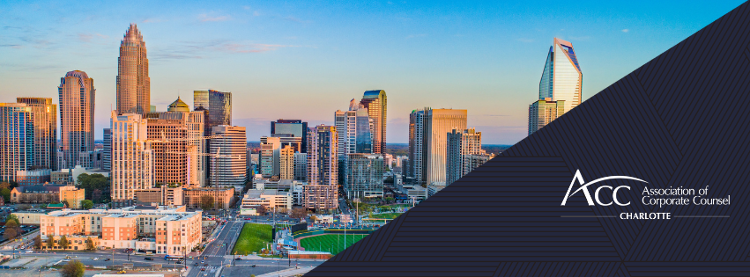
Charlotte 2024 Chapter Survey
- Have you attended any ACC Charlotte events or programs in 2023 or 2024?
  - Yes
  - No

- If yes, approximately how many did you attend in 2023-2024 to date?
  - 0
  - 1-5
  - 6-10
  - 11-15
  - 16-20
  - 20+

- If not, why? Please select all that apply.
  - Lack of time
  - Lack of interest in programs offered
  - Inconvenient location options
  - Other (Please specify)

- Do you prefer In-Person or Virtual CLEs?
  - Only In-Person
  - Only Virtual
  - Both

- Of the ACC Charlotte programs you have attended, which category of program did you attend? Select all that apply.
  - Lunch CLEs at The Hamilton (our monthly location)
  - CLE Events hosted at law firm locations or other venues
  - Webinar CLE’s
  - Social events or Women’s Events
  - Affinity group events (Manufacturing or New to In-House)
  - Professional Development
  - Community Service or Pro Bono

- Which type of CLE topics do you want more of? (Select 3)
  - AI
  - Compliance and acquisition of customer data
  - Contracts (General Provisions, Negotiating)
  - Contracts (Purchasing, Licensing Agreements, SaaS Service…)
  - Vendor Data Security & Privacy
  - Document Management/Retention
  - Employment & Labor updates and forecasting
  - Healthcare benefits (wellness programs, mental health benefits etc.)
  - Insurance Cyber policies
  - Intellectual Property
  - Internal Investigations
  - International (overseas purchasing, importing)
  - Litigation/ADR
  - Mergers & Acquisitions
  - Technology (cybersecurity, e-discovery etc.)
  - Other (Please specify)

- Do you have any suggestions on future Professional Development events that would be beneficial?

- For social and women’s events, do you prefer:
  - Networking events with food/drink
  - Specific activities with food/drink
  - A healthy mix of both types of events

- We currently offer a New to In-House Affinity Group and a Manufacturing Affinity Group. Each group offers 2 events that are generally roundtable discussions or industry tours and aren’t CLE focused. Do you recommend any other Affinity Groups? If so, share below.
  - No, I think these two are plenty
  - I think we should have additional Affinity Groups. Please enter your ideas:

- Have you ever retained or recommended services of any ACC Charlotte law firm sponsors?
  - Yes
  - No

- If so, which ones? Select any that apply.
  - Bradley
  - Parker Poe
  - Fox Rothschild
  - Shumaker
  - Troutman Pepper
  - Littler
  - Ogletree Deakins
  - Moore & Van Allen
  - Womble Bond Dickinson
  - Robinson Bradshaw
  - Alston & Bird
  - Kilpatrick
  - McGuireWoods
  - Poyner Spruill
  - Jackson Lewis
  - Winston & Strawn

- What might influence your decision to hire a law firm sponsor?

- If you want to participate in the drawing for a $100 Amazon gift card, please list your name and email. This information is considered confidential and only used for drawing purposes.

