EEOC Updated Guidance Limits Permissible Workplace COVID-19 Practices

By: Nancy A. Johnson & Lauren C. Robertson
Since March 2020, employers have navigated an ever-changing legal landscape to ensure compliance with laws concerning the COVID-19 pandemic. It should be no surprise that as pandemic circumstances continue to evolve, the U.S. Equal Employment Opportunity Commission (“EEOC”) continues to revise its guidance to adapt to changed circumstances. Most recently, on July 12, 2022, the EEOC updated its What You Should Know About COVID-19 and the ADA, the Rehabilitation Act, and Other EEO Laws (“Guidance”), with a specific emphasis on viral testing, antibody tests, reasonable accommodation requests, and other issues relating to workplace safety.
As discussed below, the EEOC effectively walks back some of its prior advice including the appropriateness of mandatory COVID-19 viral screening testing and handling of reasonable accommodation issues. The EEOC now seems focused on increasing employee protections relating to COVID-19. In this article, we will discuss both the recent updates and recommended next steps.
Is Mandatory Testing Still Allowed?
The most significant update concerns the EEOC’s position on mandatory COVID-19 viral screening testing. The EEOC makes clear an employer’s ability to conduct screening and testing measures is not unlimited and will not automatically comply with the ADA. The EEOC now advises employers will need to justify any mandatory COVID-19 screening testing in the workplace to ensure compliance with the ADA. Specifically, employers requiring testing for employees to enter or remain on-site may do so provided such measure is “job related and consistent with business necessity.”
Going forward, employers with mandatory testing policies must conduct individualized assessments considering both pandemic and individual workplace circumstances. This significant change shifts the burden to the employer of assessing whether testing meets ADA standards. Gone are the days where mandatory COVID-19 viral screening tests for employees entering the workplace will be per se or presumed permissible.
The Guidance identifies various factors employers should consider when assessing whether testing is consistent with business necessity: (1) “the level of community transmission;” (2) “the vaccination status of employees;” (3) “the accuracy and speed of processing for different types of COVID-19 viral tests;” (4) “the degree to which breakthrough infections are possible for employees who are ‘up-to-date’ on vaccinations;” (5) “the ease of transmissibility of the current variant(s);” (6) “the possible severity of illness from current variant;” (7) “what types of contacts employees may have with others in the workplace or elsewhere that they are required to work (e.g., working with medically vulnerable individuals);” and (8) “the potential impact on operations if an employee enters the workplace with COVID-19.” The Guidance does not specify whether all these factors must exist or if a “totality of circumstances” will suffice.
The Guidance also states a mandatory COVID-19 viral screening test measure will meet the “business necessity” standard if consistent with current guidance from the CDC or state/local public health authorities. What immediate practical effect this Guidance will have on employers is unclear when considering current COVID-19 community transmission. Of significance, on July 12 – the EEOC issued its updated guidance – the CDC’s Community Tracker indicated high or substantial rates of COVID-19 transmission throughout almost all the United States. And, as of August 2022, this has not changed.
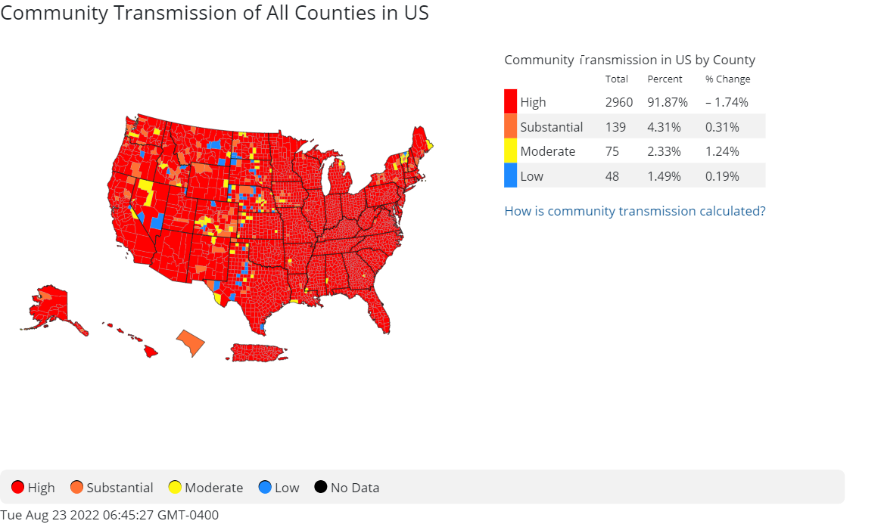
The EEOC did not, however, change its position regarding antibody testing, which is not permitted under the ADA because such testing does not identify whether an employee has a current infection or is immune.
Hiring and Screening Applicants
The updated Guidance also states employers can screen applicants for COVID-19 pre-offer if employers screen everyone entering the workplace (including visitors). The screening should be limited to the same screening given to all other individuals. If employers impose additional screening requirements on applicants, the Guidance takes the position this is an illegal pre-offer disability-related inquiry and/or medical examination.
But, can employers still withdraw an offer if an applicant has tested positive, is experiencing symptoms, or was exposed to someone with COVID-19? The answer is the classic “it depends.” Previously, the EEOC stated employers could withdraw an offer if the applicant was needed on site immediately. Now, a different test applies. The updated Guidance states employers may withdraw an offer if: (1) “the job requires an immediate start date;” (2) “CDC guidance recommends the person not be in close proximity to others;” and (3) “the job requires such proximity to others, whether at the workplace or elsewhere.”
Reasonable Accommodation Process & PPE Accommodation Requests

Previously, the EEOC’s Guidance recognized there may be pandemic-related reasons for excusable delays during the interactive process. Now, the EEOC recognizes many of these delays may no longer be excusable because of COVID-19 generally. This significant change signals the EEOC views the pandemic as having shifted to more of an endemic stage. As a result, employers must show specific pandemic-related circumstances justified a delay in providing a reasonable accommodation. Also, to the extent the delay is created by the evolving pandemic circumstances, the Guidance encourages using interim solutions to keep employees at work.
As to handling reasonable accommodation requests from COVID-19 workplace safety policies (e.g., masks or mandatory testing), the EEOC appears to return to the pre-pandemic reasonable accommodation standard with no preference towards masks or other pandemic-related measures. As a result, if an employee requests an accommodation to comply with an employer’s PPE policy, employers should engage in the interactive process and provide a reasonable accommodation unless doing so would cause an undue hardship.
What Next?
The updated Guidance is a clear reminder employers’ current practices implemented in response to the then pandemic circumstances in 2020 and 2021 may not be in line with the current legal and pandemic landscape, which continues to evolve. This is particularly true where community transmission is low. Employers should consult with counsel to evaluate their COVID-19 practices to ensure they are consistent with federal, state, and local laws. Employers also operating outside of Florida may need to implement state-specific testing requirements where the justified business necessity may be different.
Further, what may be a justified business necessity today, might not be in a few weeks. As such, employers will need to monitor and may need to make day-to-day decisions about testing based on current guidance from the CDC and state or local health departments. Moreover, some two years after the start of the pandemic, the success of COVID-related litigation is still up in the air as courts grapple with these issues. Employers should also monitor these developments and, if necessary, based on emerging trends, modify their practices. As your business navigates the road ahead of it, or when in doubt, be sure to consult experienced employment counsel.
Nancy Johnson is a shareholder at Littler, the world’s largest employment and labor law practice representing management. Based in the Orlando office, Nancy advises and defends employers who are confronted by complex workplace challenges and the evolving labor and employment landscape. najohnson@littler.com

Lauren Robertson is an associate in Littler’s Orlando office. Lauren represents employers in disputes before administrative agencies, and state and federal courts, throughout Florida. lcrobertson@littler.com

