CHAPTER ADMINISTRATOR

Request for proposals

About ACC Europe

As a leading in-house counsel association in Europe, ACC Europe promotes the interests of all in-house counsel across the region through the sharing of information, education, networking, and advocacy while demonstrating innovation, inclusion, and leadership for the benefit of the whole profession.

ACC Europe is one of the largest chapters of the Association of Corporate Counsel. The global organisation includes more than 45,000 in-house counsel members employed by over 10,000 organisations in more than 90 countries.

ACC Europe is led by a Board of Directors composed of top legal in-house professionals' team who dedicate time on a voluntary basis. At a country level, the interests of the Association are promoted through a highly dedicated team of volunteer Country Representatives.

Moreover, ACC Europe has established a number of working groups to focus on specific issues of interest for members to which ACC Europe is strongly committed. Currently the Working Groups are: Advocacy; Equity, Diversity and Inclusion; Pro bono; Wellness and wellbeing.

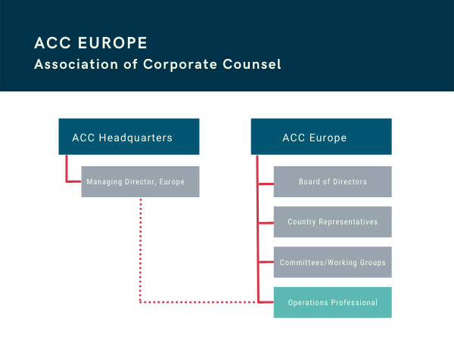

About the role

ACC Europe relies on a team to support implementing its strategy, activities, and operations, and is looking for an independent operations professional (Professional) to elevate the organisation to the next level, supporting and administering the member network.

The Professional (individual or company) is responsible for providing services to ACC Europe members through member communications, overseeing the chapter’s education programmes and networking opportunities, and developing new initiatives to enhance members’ professional and career development. It is a primary point-of-contact for members in addressing questions about membership benefits, resources, etc., and sponsors, in ensuring they are receiving a return on investment for their support.

The Professional serves as the chapter's key resource responsible for day-to-day implementation of strategy, programmes, and services.

To be successful in this position you will need to be well organised, have strong project management skills within the legal and/or association sector. You love working for a growing, values-driven organisation where you show initiative and make things happen. You thrive in a dynamic, international team where you can harness creative ideas and translate them into workable plans. You’re based in Europe, fluent in English (French and other languages are considered an asset), tech savvy and follow new digital trends. You enjoy working with diverse people. You shall be independent and not have a conflict of interest with ACC Europe nor ACC HQ.

The following section describes the main responsibilities of the Professional with an estimation of time that may be allocated to each area of work, based on experience. It also distinguishes between management related tasks and coordination/support ones. However, the Professional shall be responsible for its own organisation and task allocation. We estimate a workload of approximately 40 to 50 hours per week.

Main responsibilities

BOARD OF DIRECTORS - GOVERNANCE (15%)
Management | Administration
Responsible for board meetings, including agenda development and production of reports. | Organise Board meetings, including venue arrangements and invitations.
Create annual chapter activity report. | Attend meetings, minute-taking and follow up on action items.
Meet with the president on a regularbasis. | Assist with other responsibilities and special projects as requested/assigned by Board and as time allows.
In support to the Board’s Secretary, make sure that all business operations are in accordance with the laws and regulations.
Assist with other responsibilities and special projects as requested/assigned by Board and as time allows.

MEMBERSHIP (10%)
Management | Administration
Advise the Board on positive strategies for member engagement. | Work in collaboration with ACC HQ to process membership enquiries, members, and prospect lists.
Liaise with ACC Managing Director Europe to run programmes for lead generation. | Maintain office telephone line and email account. Answer and process communication from those sources.
 | Process correspondence.

PROGRAMMING (20%)
Management | Administration
Supervise the annual calendar of virtual, hybrid and in-person events. | Identify and invite speakers and participants, scenario/running order, brief speakers and moderator, follow-up.
Liaise with Conference Advisory Board and Chair for ensuring a smooth organisation of the ACC Europe Annual Conference. | Set up registration forms, contact and assist registrants. Extract, generate and circulate reports as necessary.
Liaise with ACC HQ to build a consistent and successful marketing and media plan for the ACC Europe Annual Conference. | Provide online logistics assistance and registration assistance during events.
 | Maintain and upload programmes to registration site.

COMMITTEES AND TASKFORCES (10%)
Management | Administration
Support committee chairs in developing initiatives which add value to the chapter’s value proposition. | Assist committee chairs in scheduling meetings on a timely basis.
Develop communications plans, and support technology selection for implementation of projects. | Attend meetings, minute-taking and follow up on action items.
Assist the Board in the organisation of Country Representative meetings and initiatives. | Send notices, keep records, and provide support when needed.

FINANCIAL (10%)
Management | Administration
Assist treasurer in annual budget preparation. | Liaise with external accountant for general reporting on organisation’s finances
Assist treasurer in filing annual required financial activity reports. | Collect and properly track sponsor payments and registration fees.
Prepare financial reports for Board meetings.
Annually, or when otherwise needed, manage bank accounts, and administer signer changes/updates.

SPONSORSHIP (20%)
Management | Administration
Build a solid network of law firms, Alternative Legal Service Providers (ALSPs) and other parties which are current sponsors or can be interested in partnering with ACC Europe. | Manage sponsorship logistics, including distributing sponsorship package to past and potential sponsors; accept submissions and maintain records for sponsor submissions, payments, and fulfilment of sponsor benefits; communicate regularly with the Board regarding sponsor issues.
 | Lead and regularly communicate with sponsors so they understand the sponsorship package and adhere to its guidelines and requirements, including but not limited to programme scheduling, promotion, and deadlines.

COMMUNICATIONS AND MEDIA (10%)
Management | Administration
Research and propose new ideas in line with emerging trends in e-marketing for associations. | Regularly update Chapter’s social media channels.
Support ACC HQ with media placements and relations with European media. | Measure effectiveness of social media posts and mass e-marketing campaigns.
Draft press releases, in coordination with ACC HQ. | Maintain chapter webpages.

ACC HEADQUARTERS (5%)
Management | Administration
Serve as key liaison with ACC Headquarters, submitting board meeting minutes, proposed Bylaw changes, assisting in the preparation of the annual chapter report, financials, and other requested information to the headquarters. | Serve as key liaison with ACC Headquarters to track membership developments (e.g., adding new prospects, welcoming new members) in Europe.
Attend online chapter administrator training sessions and meetings as offered by headquarters. | Attend chapter administrator training sessions and meetings as offered by headquarters.
Play a vital role in supporting a range of projects as part of a committed team in an organisation with global reach and impact.

- Are you an experienced association professional and project manager who has the initiative, confidence, and organisational skills to support international networks?
- Are you interested in working for a global professional association delivering services to the European in-house legal community?

How to apply
- Submit your application and services proposal including estimated fees by March 25 on the following link [Insert link]. The applications will be processed in full confidentiality.
- Interviews will take place in the first half of April.
- Preferred starting date: June/July 2022.

