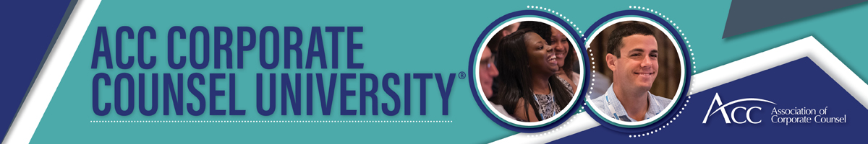

2022 ACC Corporate Counsel University®—Justification Letter

Please customize.

Dear <Insert supervisor’s name>,

I would like your approval to attend the 2022 ACC Corporate Counsel University® (CCU), June 19-21, 2022, Nashville, TN, USA. This event is specifically designed for those new to in-house practice, in-house lawyers with less than five years of experience, as well as those who simply need to sharpen their basic practice skills. The professional development opportunities are many, and attending will support our future business objectives.

Here’s what makes attending the ACC Corporate Counsel University® such a valuable investment:
- The right subject matter. I will shorten the new to in-house learning curve with practical sessions such as [insert a sampling of topics of interest to you].
- Network. I will exchange ideas and build a reliable professional network with other in-house rising stars.
- Invaluable tools. I will improve my interpersonal skills to communicate effectively.
- Guidance. I will receive guidance on building my in-house career and how to demonstrate value to our company.
- CLE/CPD credit. I can earn up to the maximum number of CLE/CPD credits approved by my jurisdiction by attending this program.
Upon my return from CCU, I will share the new ideas and key takeaways with the team to help grow our success.

I’ve provided a breakdown of approximate costs to attend CCU, and a features and benefits worksheet that specifically targets our company’s current needs and how attending this event can help provide answers for our business objectives.

I’m sure that you will agree that my attendance at the ACC Corporate Counsel University® is an excellent use of my time and will provide a good return on investment for our organization. Thank you for your consideration.

Best regards,

<your signature>

MAKE THE CASE

JUSTIFICATION DASHBOARD
Complete the following form and share it with your supervisor.

What is the cost of you attending the conference?
Registration, travel, hotel, membership fees if any.

Who is going to be there?
What relationships will you gain? Are there meaningful connections you can make?

Are there influencers who will be there?
What differentiates this conference? What are you getting here that you can’t get somewhere else?

What answers can you find there for problems your company and legal team are trying to solve?
List session names, speakers, sponsors, etc.

- continued on next page -

List at least four of the sessions or topics, with speaker names if available, you plan to attend.

2.

3.

4.

How will you value the experience of this conference?
The cost of the problems you are trying to solve, the answers you are looking for, the people you will
meet, the CLE/CPDs you will earn, etc.

