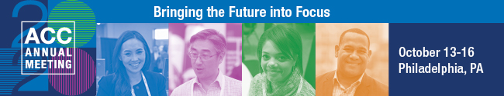

2020 ACC Annual Meeting—Justification Letter

Please customize.

Dear <Insert supervisor’s name>,

I would like your approval to attend the 2020 ACC Annual Meeting, October 13-16, 2020, in Philadelphia, Pennsylvania. This event is the world’s largest gathering of in-house counsel. The professional development opportunities are many, and attending will support our future business objectives.

Here’s what makes attending the ACC Annual meeting such a valuable investment:
- The right subject matter. I will choose from 100+ sessions and customize my education experience to sharpen my legal skills and hone-in on our company’s most pressing issues and responsibilities, such as [insert a sampling of topics of interest to you].
- Expert presenters. I will hear directly from an impressive group of legal industry thought leaders.
- Unparalleled networking. I will exchange ideas and share experiences with colleagues from around the globe with 30+ hours of networking events.
- Solutions. I will have the opportunity to get up-to-the-minute information from 100+ law firms and legal service providers.
- CLE/CPD credit. I will get the professional development I need and earn up to a year's worth of CLE/CPD credits.
Upon my return from the ACC Annual Meeting, I will share many of the new ideas and key takeaways with the team to help grow our success.

I’ve provided a breakdown of approximate costs to attend the ACC Annual Meeting and a features and benefits worksheet that specifically targets our company’s current needs and how attending this event can help provide answers for our business objectives.

I’m sure that you will agree that my attendance at the ACC Annual Meeting is an excellent use of my time and will provide a good return on investment for our organization. Thank you for your consideration.

Best regards,

<your signature>

MAKE THE CASE

JUSTIFICATION DASHBOARD
Complete the following form and share it with your supervisor.

What is the cost of you attending the meeting?
Registration, hotel, travel, etc.

Who is going to be there?
What relationships will you gain? Are there meaningful connections you can make?

Are there influencers who will be there?
What differentiates this meeting? What are you getting here that you can’t get somewhere else?

Are there any testimonials from people who have attended in the past?
Check out what previous attendees have said about the ACC Annual Meeting.

- continued on next page -

ACC Annual Meeting
Page Two

List at least four of the sessions, with speaker names, you plan to attend.

1.

2.

3.

4.

What answers can you find there for problems your company and legal team is trying to solve?
List session names, speakers, exhibitors, etc.

How will you value the experience of this meeting?
The cost of the problems you are trying to solve, the answers you are looking for, the people you will
meet, the CLE/CPDs you will earn, etc.

