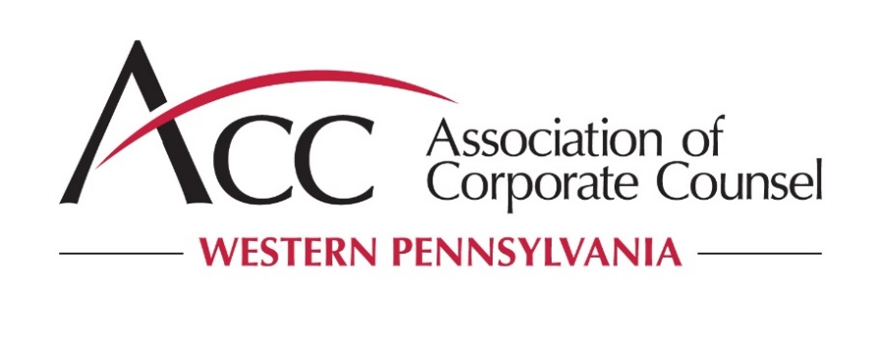
ACC Western PENNSYLVANIA
2018-2019 Sponsorship Application
Name of Sponsor:
____________________________________________________________________________
(Provide the name exactly as you want it to appear on our web page and materials.)
Primary Contact Person:
Name: ______________________________________________________________________
Title: ______________________________________________________________________
Address: ____________________________________________________________________________
Phone: ________________________________ | E-mail address: ________________________________________
Alternate contact & title: ________________________________________________________
Phone: ________________________________ | E-mail address: ________________________________________
Sponsorship Levels:
For the 2018-2019 (September 2018 – August 2019), our firm agrees to be ACC Western Pennsylvania sponsor (check one):
- Advisor and Partner Circle ($7500)
- Counselor and Collaborator Circle ($5000)
- Supporter and Educator Circle ($2000)
- Ala Carte Sponsor $____________________
Please specify your preferred program topic(s):
Topic: (1ST)__________________________________________________________________
Topic: (2ND)__________________________________________________________________
Topic: (3RD)__________________________________________________________________

____ Provide a short description for each topic proposed.
______________________________________________________________________
______________________________________________________________________
______________________________________________________________________
______________________________________________________________________
______________________________________________________________________

____ Propose speaker(s) for each topic proposed
______________________________________________________________________
____________________________________________________________________________________________________________________________________________

____ Attach biographies of the proposed speakers.

Please indicate your preferred program format(s) for each proposed topic:
CLE ________________________________________________________________________
Roundtable Discussion _________________________________________________________
Social/Sporting/Networking/Other _________________________________________________

Please indicate your preferred program time for each proposed topic:
Breakfast ____________________________________________________________________
Lunch _______________________________________________________________________
Cocktail _____________________________________________________________________
Please indicate your preferred duration for each proposed topic:
1 hour ______________________________________________________________________
2 hour ______________________________________________________________________
3 hour ______________________________________________________________________
Other ______________________________________________________________________

Preferred dates and locations: __________________________________________________________________________________________________________________________________________________

Additional comments:___________________________________________________________
______________________________________________________________________
______________________________________________________________________

If circumstances relating to the availability of your speakers arise that make it difficult or impracticable for your firm to proceed with the CLE presentation on the date scheduled, we will work with your firm to try to schedule an alternative date. However, if the parties cannot select a date that works reasonably well for both your firm and the Chapter, no refund will be issued.

By submitting this application, you confirm that you have carefully reviewed and fully understand the terms and provisions of the 2018-2019 ACC Western Pennsylvania Chapter Sponsorship Program (as contained in the 2018-2019 ACC Western Pennsylvania Chapter Sponsorship Opportunities document, the Sponsorship Levels document, and this 2018-2019 Sponsorship Application), and that you are committed to working within the Program and its requirements.
Please return this completed form as a PDF to Barb Dudek, Chapter Administrator, by e-mail at westernpa@accglobal.com.
Submitted:
By: ________________________________
Name: ________________________________
Title: ________________________________
Organization: ________________________

