Connecting to the DUGuest Network (How-to)
The following article is a set of instructions to connect to the Drake University guest wireless (DUGuest) network.

1. Connect to the DUGuest Wireless Network With Your Device
- Select the DUGuest Wireless Network from the list of available wireless networks on your device.
- Read the Acceptable Use Policy.
- Click I accept the terms.
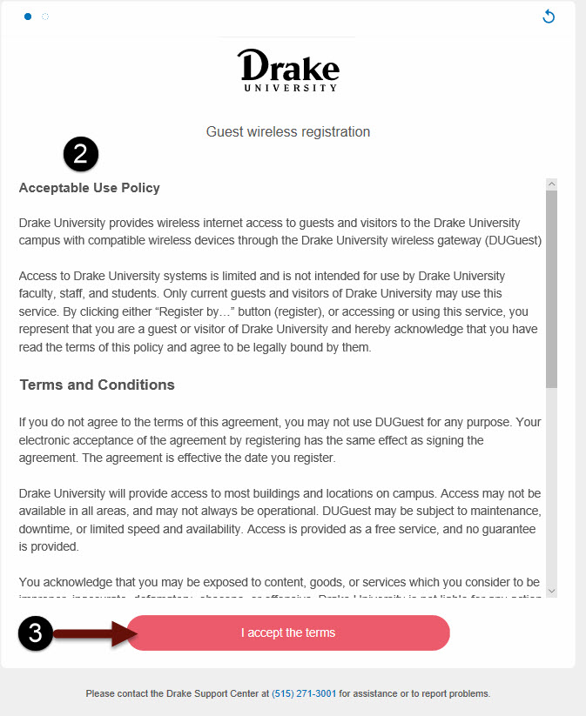

2. Fill Out The Registration Form
- Fill out the form with EMAIL and FIRSTNAME and LASTNAME.
- Click Continue.
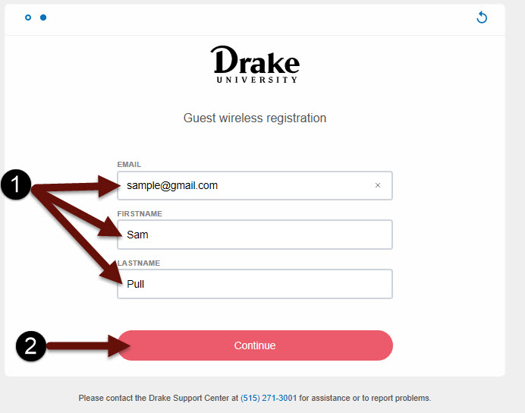

3. Confirmation of Access
This screen verifies that you have been granted access to the DUGuest network. Once your access is enabled, you will be taken to the Drake website. NOTE: Your access is granted for 23 hours.

